(Approx. 346 words)

Bits & Bytes of Memory
By Dorothy Fitch, Editor, GVR Computer Club
November 2020 issue, Green Bytes
https://www.ccgvaz.org/
dmfitch (at) cox.net

Bits and Bytes of Memory
by Dorothy Fitch, Green Bytes Editor
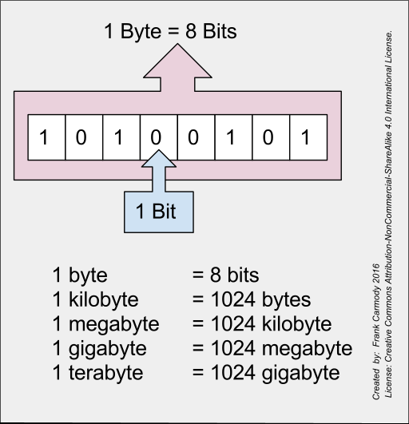
Down in these parts of AZ south of Tucson, if your memory momentarily fails you, you might say you are having a "Green Valley moment." Your computer, of course, also has memory. Let's take a look at how it is organized.
You have probably heard of bits and bytes, megabytes, and gigabytes. Do you know what each one is? What comes after a gigabyte?
A bit (BInary digiT) is like a light switch. It is either on or off. On represents a 1 and Off represents a 0. Your computer works by combining bits with each other to make larger units.
4 bits = 1 nibble, as in 0000, 0010, 0111, 1011, 1111, etc.
8 bits = 1 byte. You can do a lot more with a byte! There are 256 possible combinations of bits in a byte. A byte can store one letter of the alphabet. For example, an uppercase letter A is stored as 01000001 (which is 65 in the decimal system).
2 bytes (16 bits) = 1 word
1 megabyte (MB) = 1024 bytes (1024 is 2 to the 10th power)
1 gigabyte (GB) = 1024 megabytes
1 terabyte (TB) = 1024 gigabytes
1 petabyte (PB) = 1024 terabytes
1 exabyte (EB) = 1024 petabytes
1 yottabyte (YB) = 1024 exabytes (a yottabyte = 1 trillion terabytes)
Those are the officially recognized units of memory, However, additional ones have been proposed (each one is 1024 times the previous one): Brontobyte, Geopbyte, Saganbyte, Pijabyte, Alphabyte, Kryatbyte, Amosbyte, Pectrolbyte, Bolgerbyte, Sambobyte, etc., all the way to Blamnebyte!
You can see them all here. This website says that if you are downloading 1YB (yottabyte) of data using a super high-speed Broadband, it will take 11 trillion years to download. It's all quite mindboggling, isn't it?
Now when you have a "Green Valley moment," you can call it something classier, such as a Yottabyte moment!

